Ayush Goyal
190905522 CSE D 62

Operating Systems Week 7: Lab 6: IPC 2- Message Queue, Shared Memory

1. Process A wants to send a number to Process B. Once received, process B has to check whether the number is palindrome or not. Write a C program to implement this interprocess communication using message queue.

Code:

Producer code:

#include <stdlib.h>
#include <stdio.h>
#include <string.h>
#include <errno.h>
#include <unistd.h>
#include <sys/types.h>
#include <sys/ipc.h>
#include <sys/msg.h>

struct my_msg_st{
long int my_msg_type;
int num;
};

int main(){
int running = 1;
int msgid;
struct my_msg_st some_data;
long int msg_to_receive = 0;
msgid = msgget((key_t)1234, 0666 | IPC_CREAT);
if(msgid == -1){
perror("msgget failed");
exit(EXIT_FAILURE);
}
while(running){
printf("Enter a number : ");
int n;
scanf("%d", &n);
some_data.my_msg_type = 1;
some_data.num = n;
if(msgsnd(msgid, (void *)&some_data, sizeof(msgid), 0) == -1){
perror("msgsnd failed");
exit(EXIT_FAILURE);
}
if(n == -1){
running = 0;
}
}
exit(EXIT_SUCCESS);
}

Consumer Code:

#include <stdlib.h>
#include <stdio.h>
#include <string.h>
#include <errno.h>
#include <unistd.h>
#include <sys/types.h>
#include <sys/ipc.h>
#include <sys/msg.h>

struct my_msg_st{
long int my_msg_type;
int num;
};

int ispalin(int t){
int arr[100], n = 0;
while(t >0){
int dig = t%10;
t/=10;
arr[n++] = dig;
}
for(int i = 0; i<n/2; i++){
if(arr[i] != arr[n-i-1]){
return 0;
}
}
return 1;
}

int main(){
int running = 1;
int msgid;
struct my_msg_st some_data;
long int msg_to_receive = 0;
msgid = msgget((key_t)1234, 0666 | IPC_CREAT);
if(msgid == -1){
perror("msgget failed");
exit(EXIT_FAILURE);
}
while (running){
if(msgrcv(msgid, (void *)&some_data, sizeof(msgid), msg_to_receive, 0) == -1){
perror("msgrcv failed");
exit(EXIT_FAILURE);
}
if(some_data.num == -1){
running = 0;
}
else if(ispalin(some_data.num)){
printf("%d is a palindrome\n", some_data.num);
}
else{
printf("%d is not a palindrome\n", some_data.num);
}
}
if(msgctl(msgid, IPC_RMID, 0) == -1){
perror("msgctl failed");
exit(EXIT_FAILURE);
}
exit(EXIT_SUCCESS);
}

Output:

Producer Terminal:

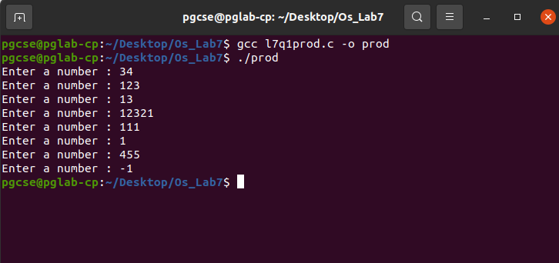
Consumer Terminal:

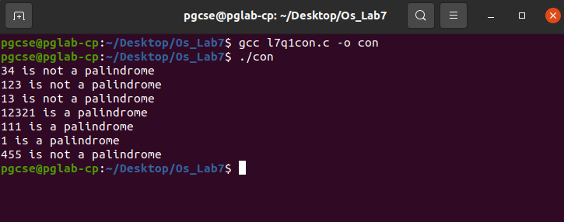
2. Implement a parent process, which sends an English alphabet to a child process using shared memory. The child process responds with the next English Alphbet to the parent. The parent displays the reply from the child.

Code:

#include <unistd.h>
#include <stdlib.h>
#include <stdio.h>
#include <string.h>
#include <sys/types.h>
#include <sys/ipc.h>
#include <sys/shm.h>
#include <sys/wait.h>

struct shared_use_st{
char alphabet;
};

int main(){
void *shared_memory = (void *)0;
struct shared_use_st *shared_stuff;
char alphatosend;
pid_t pid;
int status;
int smid = shmget((key_t)1234, sizeof(struct shared_use_st), 0666 | IPC_CREAT);
if(smid == -1){
printf("shmget failed!\n");
exit(0);
}
shared_memory = shmat(smid, (void *)0, 0);
if(shared_memory == (void *)-1){
printf("shmat failed!\n");
exit(0);
}
printf("Memory attached at %X\n", (int)shared_memory);
shared_stuff = (struct shard_use_st *)shared_memory;
printf("Enter an alphabet : ");
scanf("%c", &alphatosend);
shared_stuff->alphabet = alphatosend;
printf("\nParent process wrote to shared memory\n");
pid = fork();
if(pid == 0){
printf("\nInside child process ...\n");
char alphabet = shared_stuff->alphabet;
if(alphabet == 'z'){
alphabet = 'a';
}
else if (alphabet == 'Z'){
alphabet = 'A';
}
else
alphabet = (char)((int)alphabet + 1);
shared_stuff->alphabet = alphabet;
printf("Child process updated shared memory\n");
}
else{
wait(&status);
printf("\nInside parent process...\n");
printf("Alphabet in shared memory: %c\n", shared_stuff->alphabet);
}
}

Output:

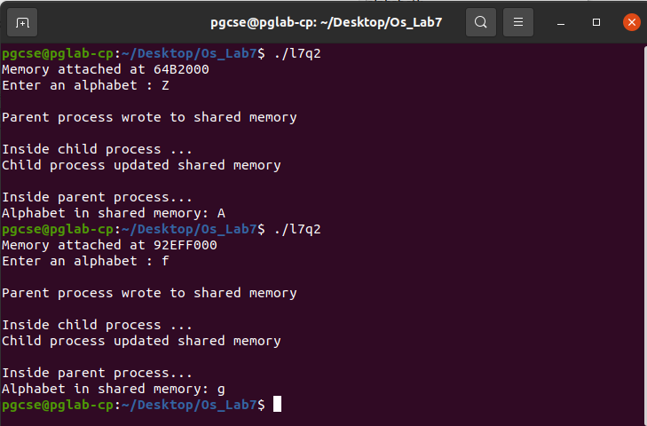

THE END

